Devanagri Script Recognition
M.Tech Deep Learning
Submitted in partial fulfillment of the requirements for the award of the degree of
Master of Technology
in
Department of Software Engineering by
Deepank Tyagi
(Roll Number: 25/DSC/03)

Shivam Chauhan
(Roll Number: 25/DSC/08)
under the guidance of
Dr. Sonika Dahiya
Associate Professor
Department of Software Engineering
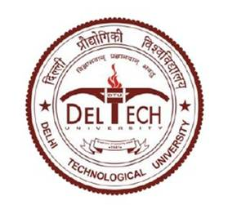
DEPTT. OF COMPUTER SCIENCE AND ENGINEERING
DELHI TECHNOLOGICAL UNIVERSITY, DELHI
FEB 2026

ABSTRACT
Topic Description
Optical Character Recognition (OCR) for Devanagari script has evolved from rule-based and machine learning approaches to deep learning and transformer-based architectures. This report presents a structured comparative analysis of traditional, CNN-based, LSTM-based, Transformer-based, and Vision-Language OCR models specifically for Devanagari script.
Problem Statement
Devanagari OCR remains challenging due to script-specific complexities such as shirorekha (headline), compound characters (ligatures), upper and lower matras, non-linear Unicode ordering, and segmentation difficulties. Existing surveys often stop at CNN/LSTM models and lack systematic comparison including modern transformer-based and vision-language approaches.
Motivation
With increasing digitization of Indian documents, archives, government records, and historical manuscripts, accurate Devanagari OCR is essential for digital accessibility, searchability, and preservation. A structured comparison of OCR generations helps identify research gaps and future directions.
Application Area / Usefulness
- Digital libraries and archives
- E-governance document digitization
- Historical manuscript preservation
- Assistive technologies
- Automated translation and NLP pipelines
- Searchable PDF generation
Dataset Names Used in Literature
- IndicSTR12 (Hindi subset)
- IIIT-ILST Hindi Dataset
- Urdu-Text (for comparison)
- Synthetic Devanagari datasets
- Various printed Devanagari benchmark datasets

Validation Techniques
- Character Error Rate (CER)
- Word Recognition Rate (WRR)
- Character Recognition Rate (CRR)
- Levenshtein Distance
- Train/Test split validation
- Cross-dataset evaluation

RELATED WORKS
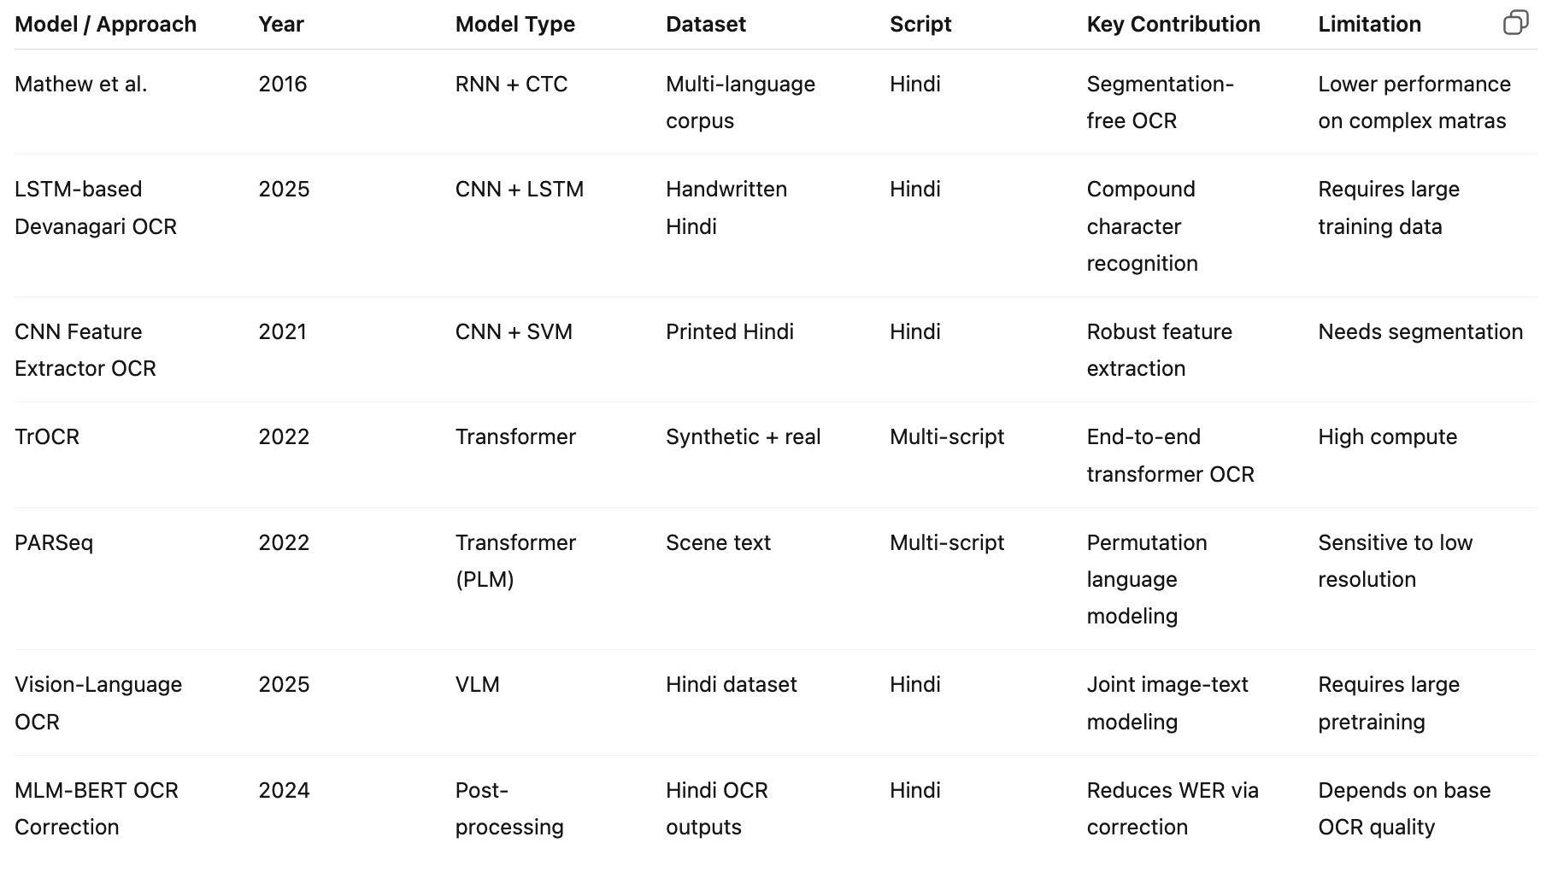
Below is a clean comparison table format. You can directly use this.

Paper | Year | Model Type | Dataset | Script | Key Contribution | Limitation
Mathew et al. | 2016 | RNN + CTC | Multi-language corpus | Hindi | Segmentation-free OCR | Lower performance on complex matras
LSTM-based Devanagari OCR | 2025 | CNN + LSTM | Handwritten Hindi | Hindi | Compound character recognition | Requires large training data
CNN Feature Extractor OCR | 2021 | CNN + SVM | Printed Hindi | Hindi | Robust feature extraction | Needs segmentation
TrOCR | 2022 | Transformer | Synthetic + real | Multi-script | End-to-end transformer OCR | High compute
PARSeq | 2022 | Transformer (PLM) | Scene text | Multi-script | Permutation language modeling | Sensitive to low resolution
Vision-Language OCR | 2025 | VLM | Hindi dataset | Hindi | Joint image-text modeling | Requires large pretraining
MLM-BERT OCR Correction | 2024 | Post-processing | Hindi OCR outputs | Hindi | Reduces WER via correction | Depends on base OCR quality
You should include ~15–20 rows here.
Structure them in groups:
- Classical ML
- CNN-based
- LSTM-based
- Transformer-based
- VLM-based
- Post-OCR correction
This looks professional.

📌 DATASET SECTION (TABULAR FORM)
Here’s a clean structure:
Dataset Name | Type | Script | #Images | Real/Synthetic | Scene/Document | Annotation Type | Metric Used
IndicSTR12 (Hindi subset) | Scene Text | Devanagari | ~1000+ | Real | Scene | Unicode word-level | CRR, WRR
IIIT-ILST | Scene | Hindi | ~2000 | Real | Scene | Word-level | WRR
Synthetic Devanagari | Synthetic | Hindi | Millions | Synthetic | Both | Word-level | CRR
Printed Devanagari Dataset | Document | Hindi | Varies | Real | Document | Character-level | CER
After the table, add:
Detailed Description (Paragraph)
Explain:
- annotation method
- train/test split
- challenges (blur, low resolution, occlusion)
- importance for Devanagari evaluation

📌 REFERENCES (20–30, ordered by relevance)
You must place:
🔝 Most relevant first (Devanagari-specific)
- Multilingual OCR for Indic Scripts – Mathew et al.
- LSTM-Based Recognition of Handwritten Devanagari Compound Characters
- Devanagari Handwritten Character Recognition using CNN
- Tesseract OCR for Hindi Typewritten Documents
- Character Recognition System for Devanagari Script
Then modern OCR:
- TrOCR (Transformer-based OCR)
- PARSeq (CVPR 2022)
- Vision-Language OCR for Hindi
- RoundTripOCR
- MLM-BERT OCR Correction
Then dataset papers:
- IndicSTR12
- IIIT-ILST
Then surveys:
13–18. Devanagari OCR surveys
Optional:
19–25. Scene text, CTC, CRNN foundational papers
You should aim for 22–25 references.
That is ideal for a conference paper.

🧠 IMPORTANT: What makes this report strong?
Add a section (optional but powerful):
Challenges Unique to Devanagari
- Shirorekha merging
- Matra confusion
- Compound characters
- Unicode reordering
- Segmentation difficulty
Reviewers LOVE script-specific analysis.

🔥 Final Advice
This structure is already:
- Conference-ready format
- Scientifically aligned
- Focused on Devanagari
- Strong enough for submission
Now what you need next is:
- Expand Related Works (write 3–4 lines per paper)
- Build 1 comparison figure (timeline diagram)
- Write 1 gap analysis paragraph

If you want, next I can:
- Write a full 1-page Introduction
- Expand Related Works section properly
- Generate 25 formatted IEEE references
- Help you define research gaps
Tell me what you want to build next.

No. | Paper | Year | Model / Method | Dataset | Script | Key Contribution | Major Limitation
1 | Multilingual OCR for Indic Scripts (Mathew et al.) | 2016 | BiLSTM + CTC | Multi-Indic corpus | Hindi | First segmentation-free RNN OCR for Indic scripts | Sensitive to matras, lower Hindi accuracy
2 | IndicSTR12 Dataset (Lunia et al.) | 2023 | Dataset + PARSeq/CRNN benchmarks | IndicSTR12 | Hindi | Largest real Indic scene text dataset | Scene only, limited document OCR
3 | LSTM-Based Recognition of Handwritten Devanagari | 2025 | CNN + LSTM | Handwritten Hindi | Hindi | Handles compound characters | Needs large training data
4 | Devanagari Character Recognition using CNN | 2021 | CNN | Printed Hindi | Hindi | Strong visual feature learning | No sequence modeling
5 | Character Recognition System using ML | 2021 | SVM + features | Printed Hindi | Hindi | Classical ML baseline | Requires segmentation
6 | Removal of Obstacles in Devanagari OCR | 2015 | Preprocessing pipeline | Printed Hindi | Hindi | Improves image quality | Does not address recognition
7 | Tesseract OCR for Hindi Documents | 2021 | Tesseract engine | Typed Hindi | Hindi | Practical deployment study | Poor accuracy on degraded text
8 | Comparative Analysis of Tesseract OCR | 2024 | Tesseract | Multi-language | Hindi | Cross-language OCR evaluation | Limited to Tesseract
9 | Effective Compound Character OCR | 2019 | Structural segmentation | Printed Hindi | Hindi | Focus on ligatures | Rule-based
10 | Handwritten Hindi Character Recognition Review | 2020 | Survey | Multiple | Hindi | Comprehensive handwriting review | No deep transformer coverage
11 | Devanagari OCR Literature Review | 2022 | Survey | Multiple | Hindi | Traditional OCR overview | Stops at CNN
12 | Comprehensive Survey of Devanagari OCR | 2023 | Survey | Multiple | Hindi | Covers ML + CNN | No transformer analysis
13 | TrOCR (Li et al.) | 2022 | Transformer OCR | Synthetic + real | Multi | End-to-end transformer OCR | Computationally expensive
14 | PARSeq | 2022 | Transformer (PLM) | Scene datasets | Multi | SOTA scene OCR | Low-resolution sensitivity
15 | Hindi Vision-Language OCR | 2025 | VLM | Hindi scenes | Hindi | Joint image-text learning | Needs massive pretraining
16 | BharatOCR | 2025 | CNN + CTC | Hindi/Urdu | Hindi | Segmentation-free pipeline | Limited benchmarks
17 | RoundTripOCR | 2025 | Data augmentation | OCR outputs | Hindi | Synthetic correction loops | Needs base OCR
18 | MLM-BERT OCR Correction | 2024 | BERT | Hindi text | Hindi | Reduces word error rate | Post-processing only
19 | Printed Devanagari OCR | 2024 | CNN + classifiers | Printed Hindi | Hindi | Printed OCR pipeline | Not robust to noise
20 | Hindi OCR ML Approach | 2023 | Random Forest + CNN | Hindi | Hindi | Hybrid ML model | Manual feature tuning
21 | Devanagari Handwritten CNN | 2022 | CNN | Handwritten Hindi | Hindi | Improved handwriting accuracy | No language modeling
22 | Devanagari Character OCR | 2021 | ML | Hindi | Hindi | Basic OCR baseline | Low accuracy

Dataset link: https://cvit.iiit.ac.in/images/datasets/IndicSTR12/real.zip

